PlaceHolder Navigation System

User Manual

Made by Placeholder©
Weishi Li, Hao Wang, Xinyu Zhang, Junfeng Chen

Table of Contents
Table of Contents 2
Glossary 3
Version History 4
Overview of System 5
Basic Features 5
Usage Instructions/Scenario(s) 5
Advanced Features 9
Installation 10
System requirements 10
Setup & Configuration 10
Uninstalling 10

Glossary

Term | Definition
Tab Delimited | A file that separates rows of data points with a Tab and columns of data with a return.

Version History
Ver 0.01 updated by 10/02/2021
Write the outline and basic information about Atlas.
Alpha release 1 updated by 10/18/2021
Login window and basic function for picking up one item.
Beta release 1 updated by 11/14/2021
Support multiple products route, finding product location and more explanation on GUI
Beta release 2 updated by 11/28/2021
Multiple item pick-up directions added to choosePoint and updated GUI.
Support input order list by a txt file.
Final release updated by 12/4/2021
Add “select order list” function, and improve the algorithms for optimal routes

Overview of System

Basic Features
Enter the productID and the system will give the workers its location or the route.

Usage Instructions/Scenario(s)
- Run the executable file to start the system.
- Select map of the warehouse, as shown in Figure 1.
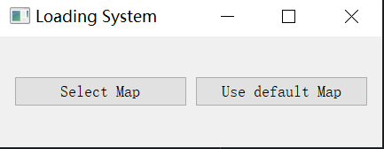
Figure 1 Map Loading System
Next, enter the order list loading system, as shown in Figure 2.
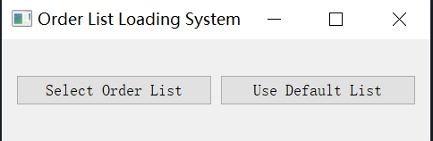
Figure 2 Order list Loading System
For example, if we use the default map and default order list, a Navigation Window will be displayed, as shown in Figure 3.
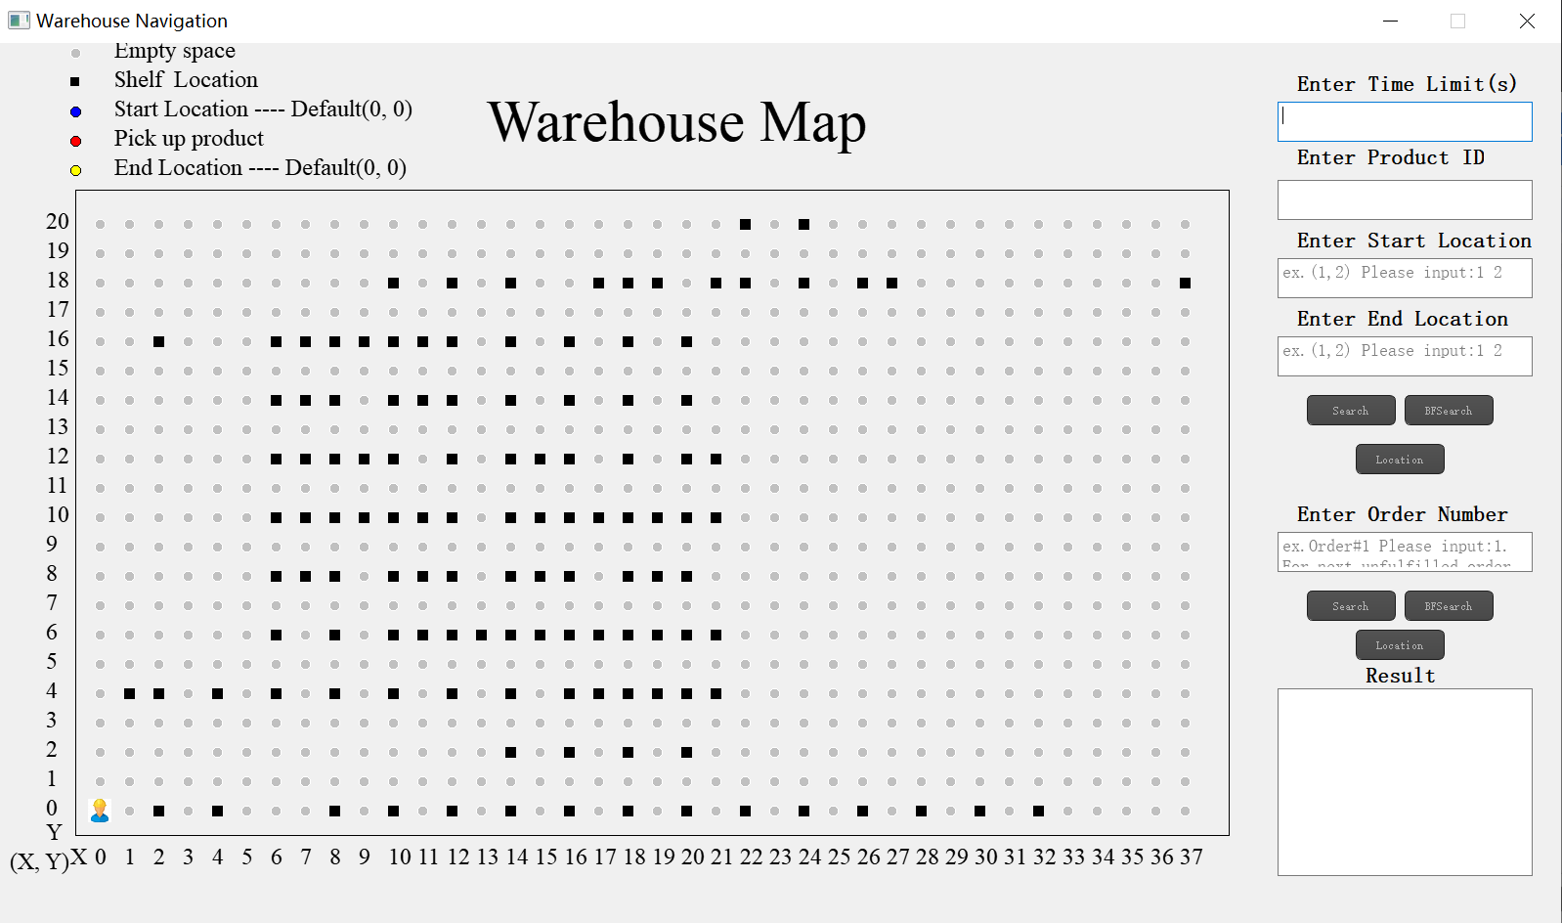
Figure 3 Default Warehouse Navigation Window
- Enter the product ID, and click ‘search’ or ‘BFSearch’, then the system will show the route, as shown in Figure 3. The route, path length and time interval will be displayed in the result window. Besides, the selected product is highlighted with yellow color.
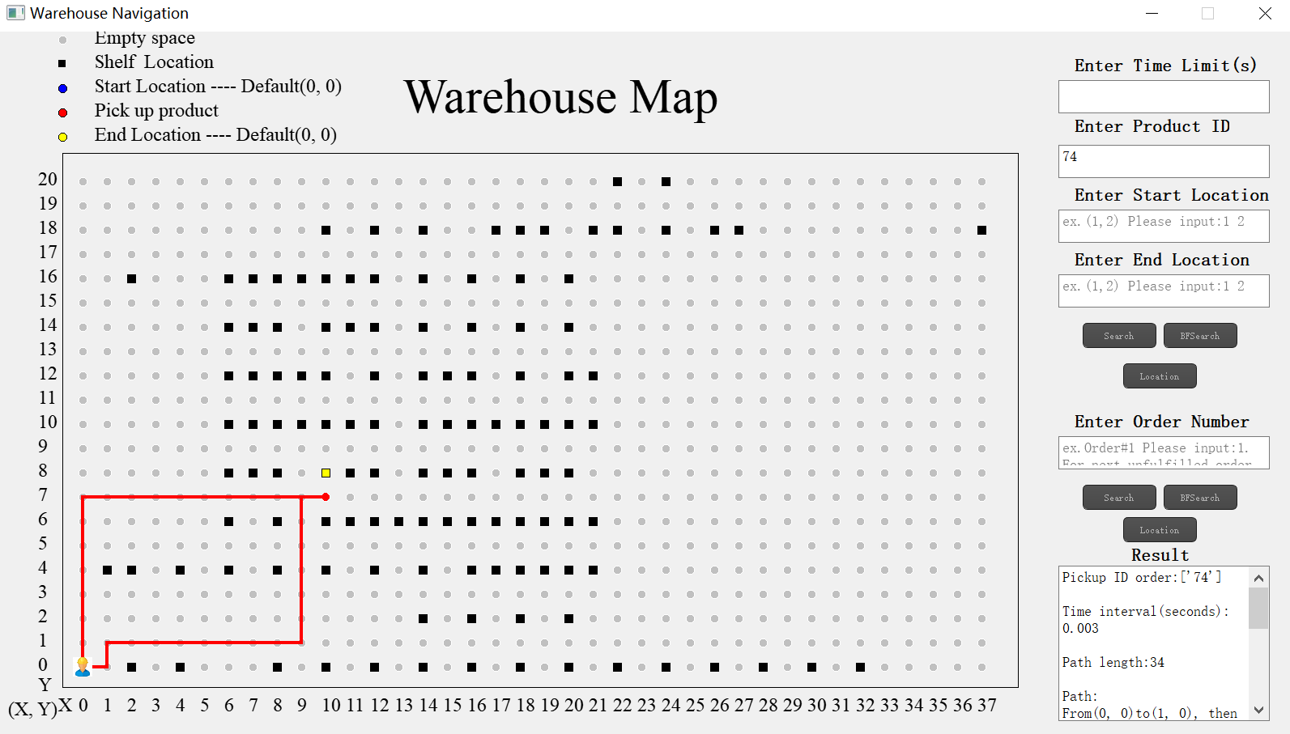
Figure 4 Route for given product ID

- If users only want to look up the product location, then they need to input the product ID and click the ‘Location’ button.
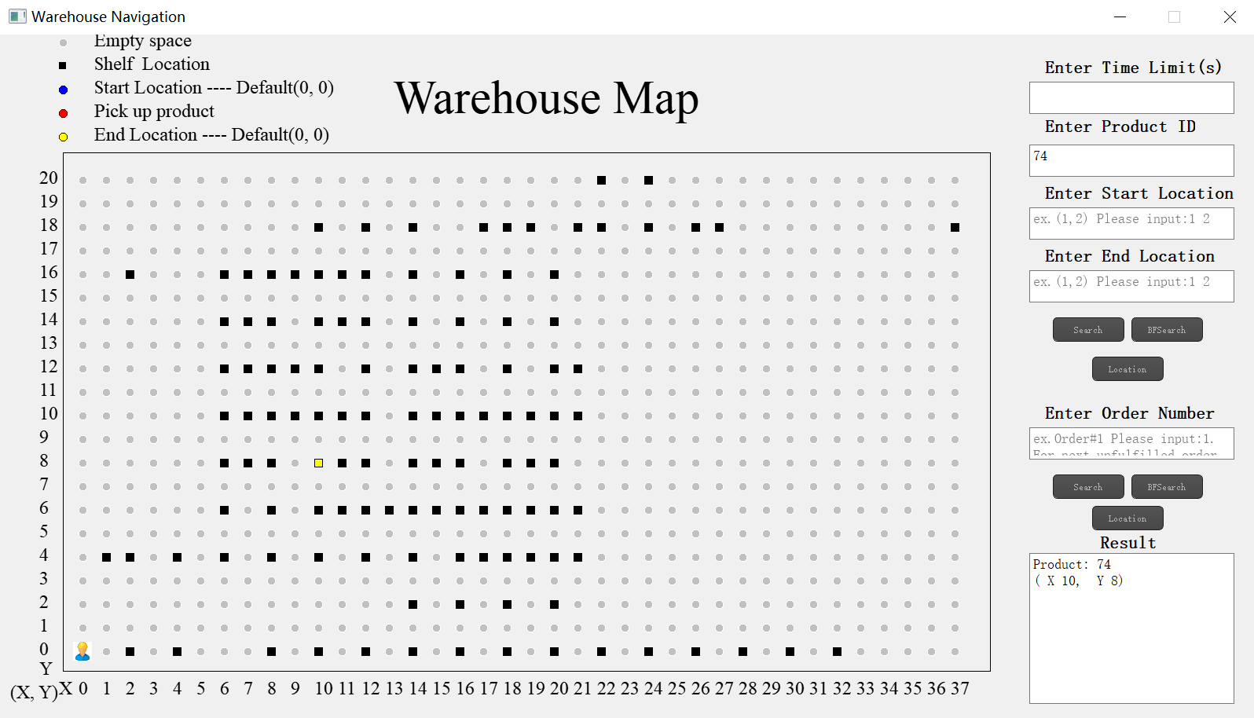
Figure 5 Demonstration for looking up location

- Users can choose the start location and end location, the system will show the route, as shown in Figure 6.
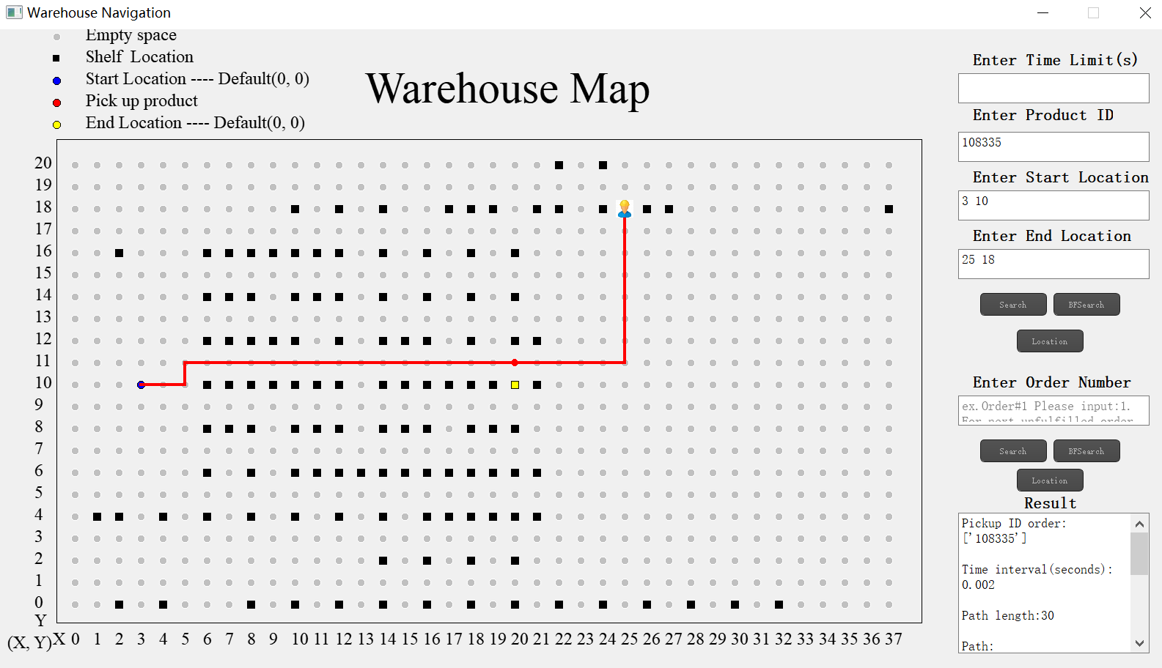
Figure 6 Route for given product ID, start location and end location

- The system allows multiple productID(more details in Advanced Features: enter multiple id) in one ride. If the worker has to pick up several items, this function will plan the optimal route based on the location of the items.
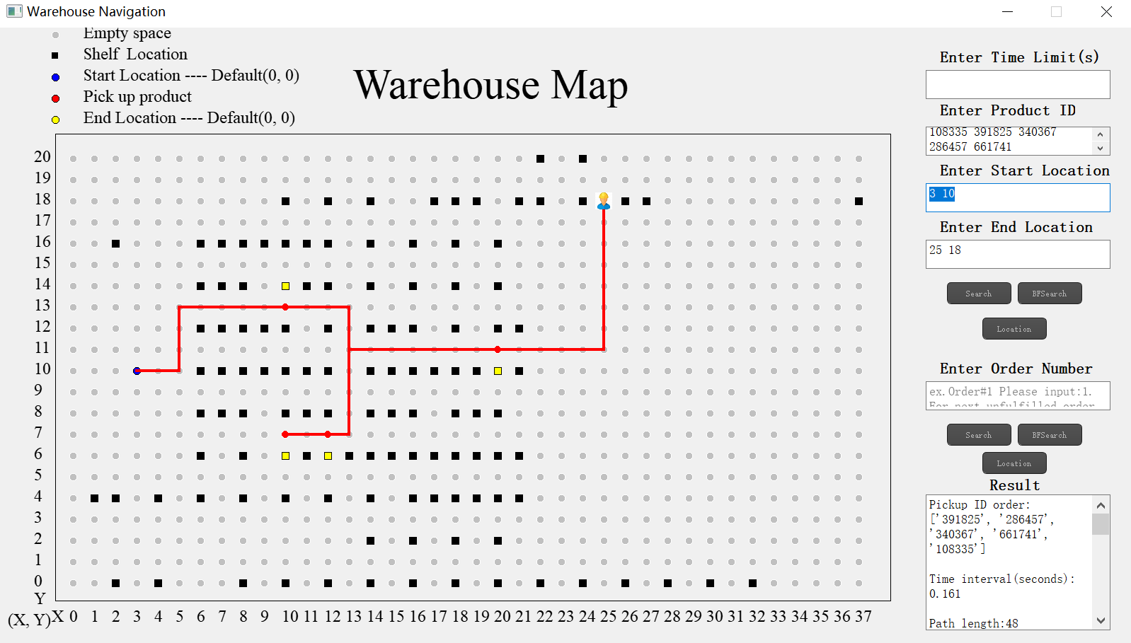
Figure 7 Route for multiple product ID, custom start location and end location

- The time limit could be defined by users. For example, As the result window shows BFsearch by 5 products with a time limit of 30 seconds.
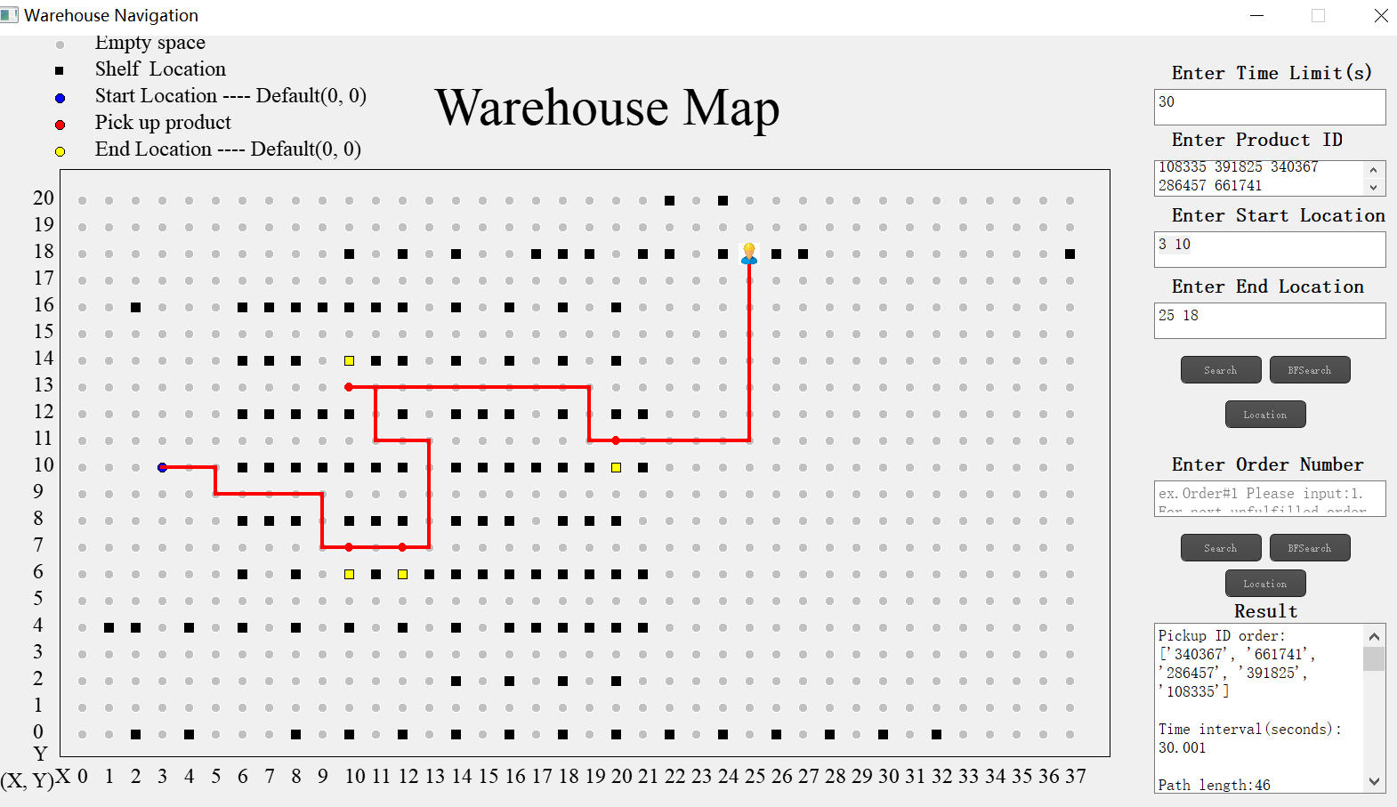
Figure 8 Demonstration for change time limit

- Order list can be inputted via file input “qvBox-warehouse-orders-list-part01”. It stores 100 different combinations of products. Users could input the number of orders rather than specific product IDs.
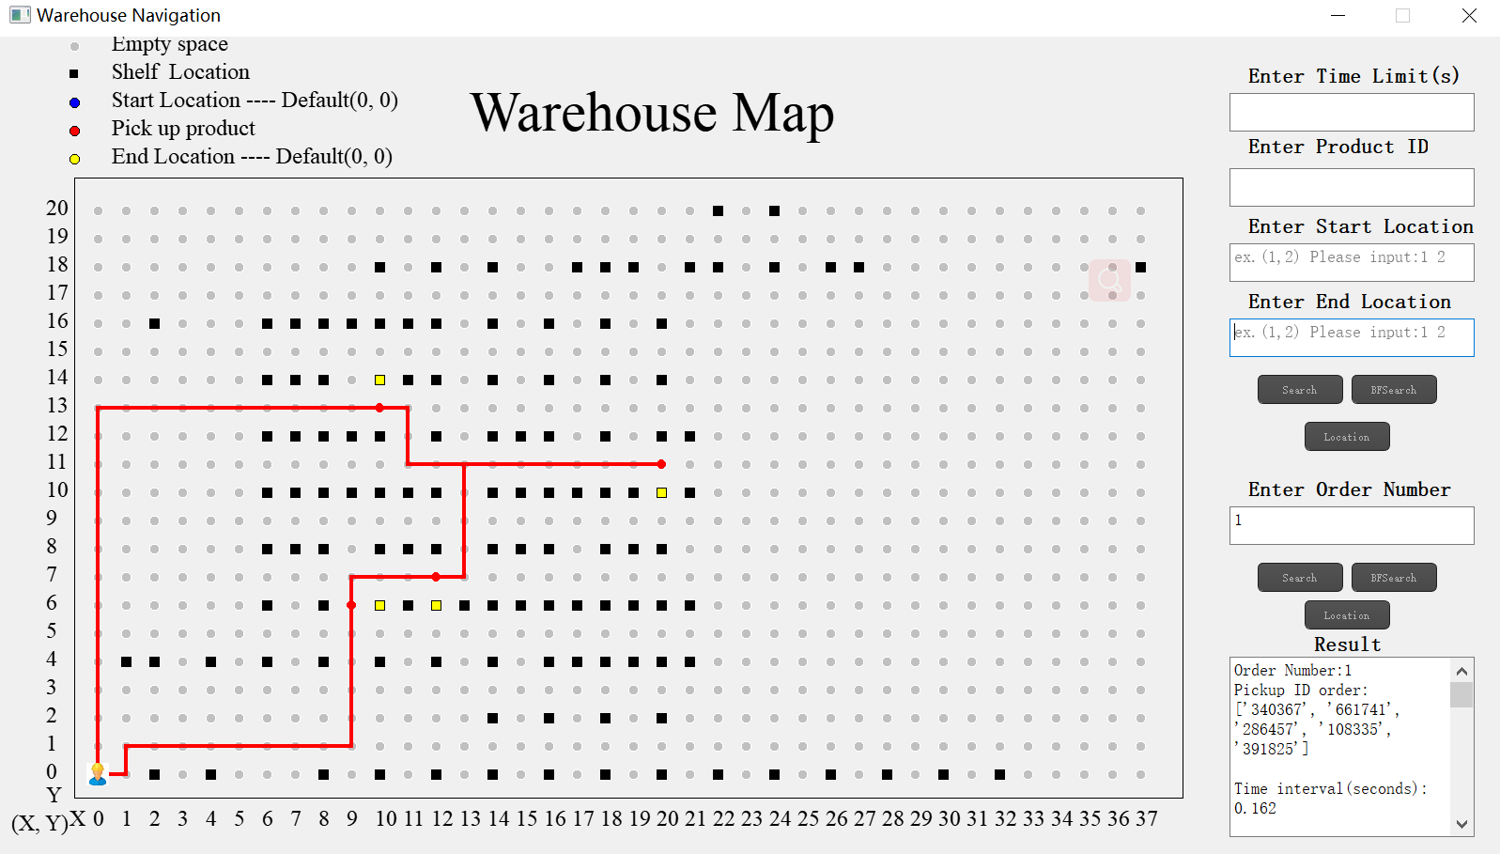
Figure 9 Demonstration for input order number

- After task are finished, users could click ‘x’ to quit the system

Advanced Features
UI
Enter multiple ids, and then give you the quickest/ most efficient route
Dynamic start/end locations (user inputted)
Select the map, order list
Different algorithms for planning a route

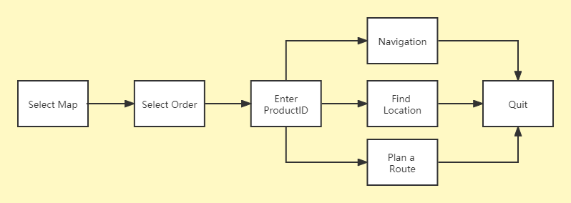
Figure 9 Diagram of system

Installation

System requirements
Win10 64 Bit/ Mac/ Linux
2 GB of RAM
1 GB Hard drive space

Setup & Configuration
Install python3 on windows/mac/linux

Uninstalling

simply just delete executable file and other file in the zip

